Assignment 13 (December 5- December 17)

1. Let 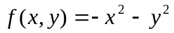, and we seek to maximize that function subject to constraint 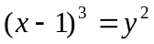. Solve that problem with and without the additional Lagrange multiplier 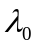.

2. Find the critical points in the problem of constrained optimization and classify them using the second-order conditions: 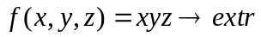,
subject to 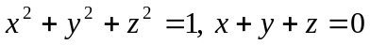.

3. The weekly production of a factory depends on the amounts of capital and labor it employs by the formula 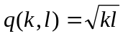. The cost of capital is $4 per unit and the cost of labor is $1. Find the minimum weekly cost of producing 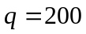.
How the cost of production changes if the factory has to produce 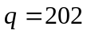?

4. A firm’s inventory 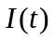is depleted at a constant rate per unit time, i.e. 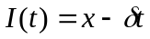, where is an amount of good reordered by the firm whenever the level of inventory is zero. The order is fulfilled immediately. The annual requirement for the commodity is  and the firm orders the commodity times a year where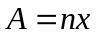. The firm incurs two types of inventory costs: a holding cost and an ordering cost. Since the average stock of inventory is 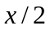 the holding cost equals 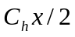, the cost of placing one order is 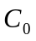 and with orders a year this cost equals 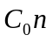.
a) Minimize the cost of inventory 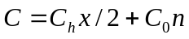 by choice of and subject to the constraint by the Lagrange multiplier method.
b) Using the envelope theorem interpret the Lagrange multiplier.

5. Use the Lagrange multipliers to find the dimensions of a rectangular box with the least possible surface area among those with a volume of 27 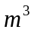. Check the second-order conditions. Evaluate the change in the minimal surface area if the volume drops by 0.5 m³. Compare your estimate with the direct computation.

